SPARK4MIND

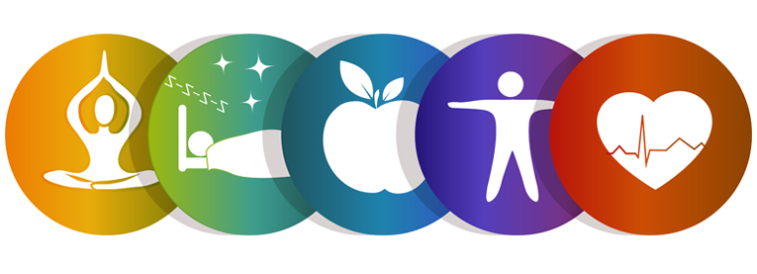

**Team:: 4**

**Team Members::**

* Barath Naravula Loganathan - 35
* Aishvwarya Natarajan Iyer - 19
* Gayathree Natarajan Iyer - 20
* Megha Nagabhushan - 32

**Table of Contents**

**Topic Page No.**

I Introduction 2

II Project Goal and Objectives 3

III Project Plan 4

IV Increment Report 8

V Implementation 19

VI Testing 39

VII Technology Used 40

VIII Project Management 41

IX Bibliography 43

1. **Introduction**

Stress within your comfort zone can help you perform under pressure, motivate you to do your best, even keep you safe when danger looms. But when stress becomes overwhelming, it can damage your mood and relationships, and lead to a host of serious mental and physical health problems. The trouble is that modern life is so full of frustrations, deadlines, and demands that many of us don’t even realize how stressed we are. By recognizing the symptoms and causes of stress, you can take the first steps to reducing its harmful effects and improving your quality of life.

This application will help users cope up the stress with spending 10-15 minutes with this stress buster application. This application will provide user the refreshing 10-15 minutes which would help them better concentrate on their job or studies.

This application will take a stress test of the user and based on the inputs provided by the user, it will calculate the level of stress. User can further play games, watch funny videos, yoga exercises, watch motivational videos, listen to some soothing music to get rid of the stress. Based on multiple usage, user will be able to view their own progress graph and give feedback based on it.

**II. Project Goal and Objectives**

* **Overall goal**

Makes the mind and soul of the application user peaceful and stress free.

* **Specific objectives**

When user is under lot of pressure, frustration, workload, personal or professional issues the objective of this application is to relieve the stress of users within 10-15 minutes. This application will help users to know the stress level and help users cope up the stress with some videos, songs, games, yoga exercises.

Idea Inspired by TED talk, idea worth Spreading, “All it takes is 10 mindful minutes“ by Andy Puddicombe.

* **Specific features**
* Stress level tester
* Interactive stress-reliever games
* Structured and Proven weekly course work for stress-free and more-success life
* Medical brain wave music according to user focus improvement
* Motivation video tailored specific to user
* Yoga or Mediation training videos to different age group
* Checking progress of user
* Give feedback
* **Significance**

Being human being in this busy world is a little difficult one but being a successful human being in this world is more difficult than climbing the Mount Everest. To be successful, we need to be stress-free, worry-less, focus-more and train-more. This is where our App idea comes into play so that a human being can climb the ladder of success and become a good human being.

**III. Project Plan**

**Schedule for the four different increments**

Increment 1: Launch page

Login page

Registration page

Stress Test page

Increment 2: Integrating YouTube videos

* + - * + Motivational videos
        + Funny videos
        + Yoga videos
        + Stress relieving exercise videos

Integrating soothing music

Increment 3: Music Player

NYTimes API

Articles API

Feedback form

Increment 4: Deployment

Testing

**Stories (Issues): Scenario & Use case specification**

* The user first logs in to the application or signs up if not registered.
* The user will answer various questions and the stress meter will specify the stress level.
* Depending on the user’s stress level user can select among many stress relieving options like: Games, Music, Videos.
* If the user selects videos, user will have various options like yoga exercises, inspirational talks, music video etc.
* Once the user is done with it, there will be a graph that shows the improvement in his/her stress level.
* Later on, user can provide feedbacks for the application.
* User logs out of the application and is stress free!

**Project Timelines, Members, Task Responsibility**

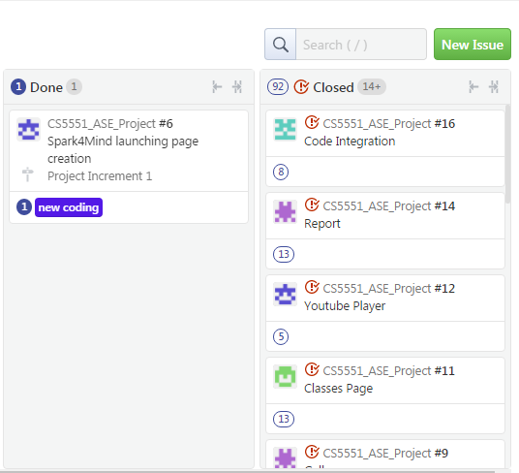

**Burndown chart**

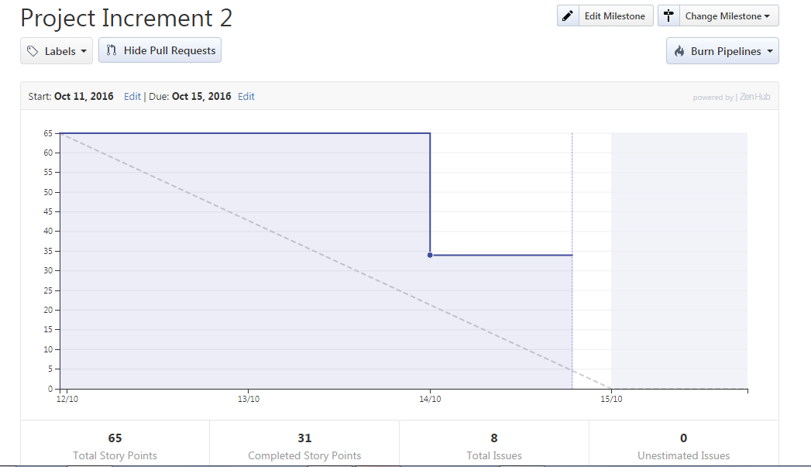

**IV. Increment Report**

**Detailed Design of Features**

**Wireframes**

1. **Wireframe for Login page**

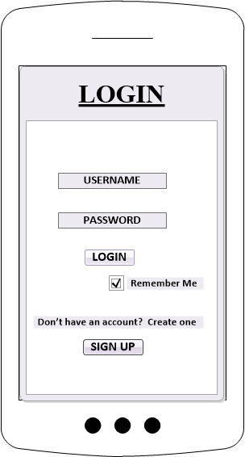

1. **Wireframe for Registration page**

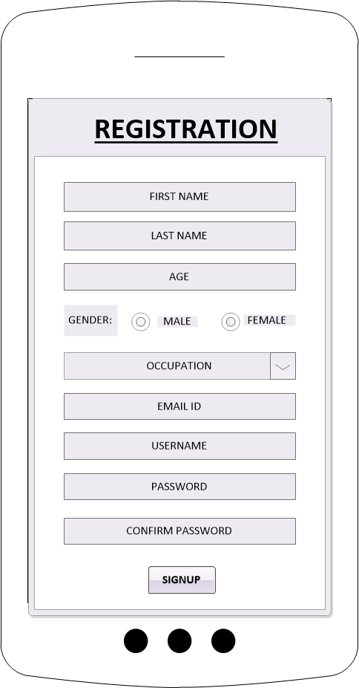

1. **Wireframe for Stress Test page**

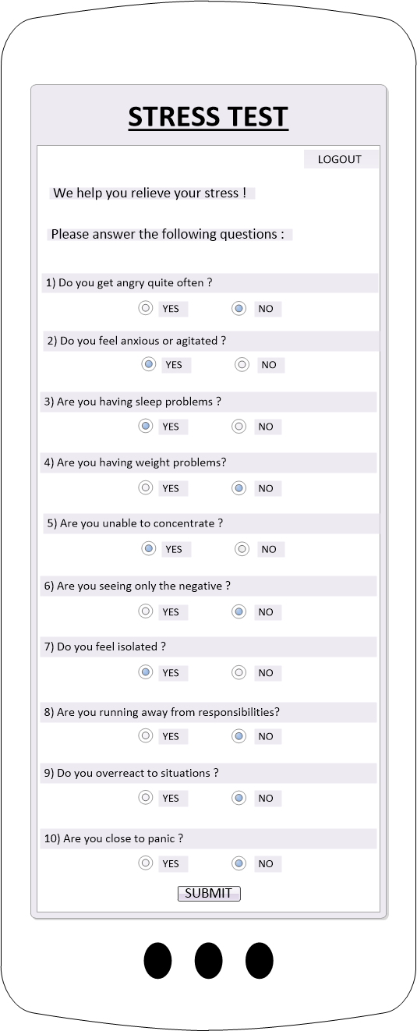

1. **Wireframe for Class page**

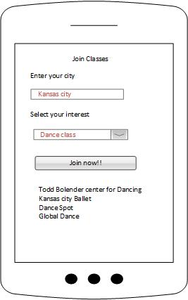

1. **Wireframe for Gallery page**

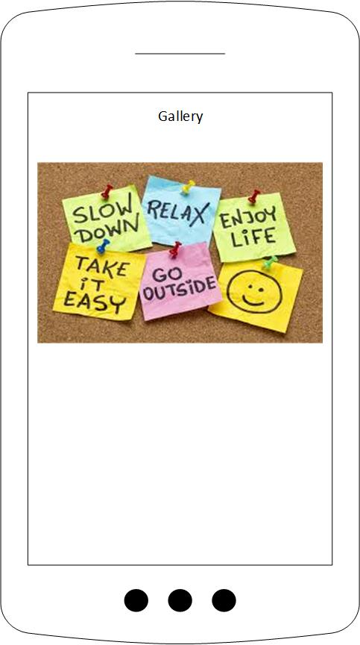

1. **Wireframe for Home page**

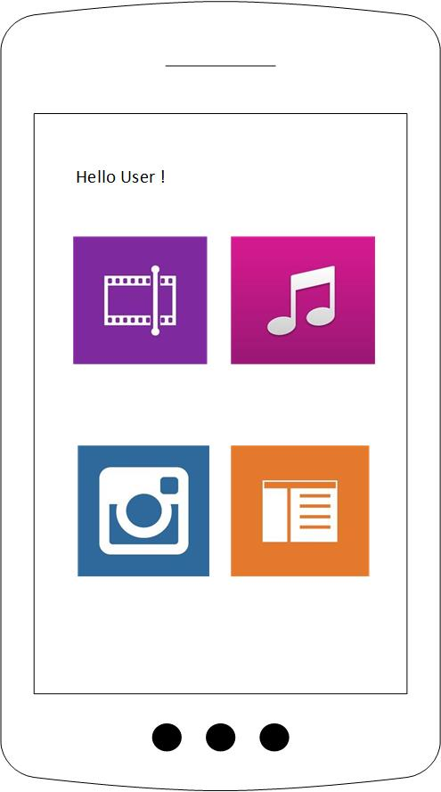

**Class Diagram**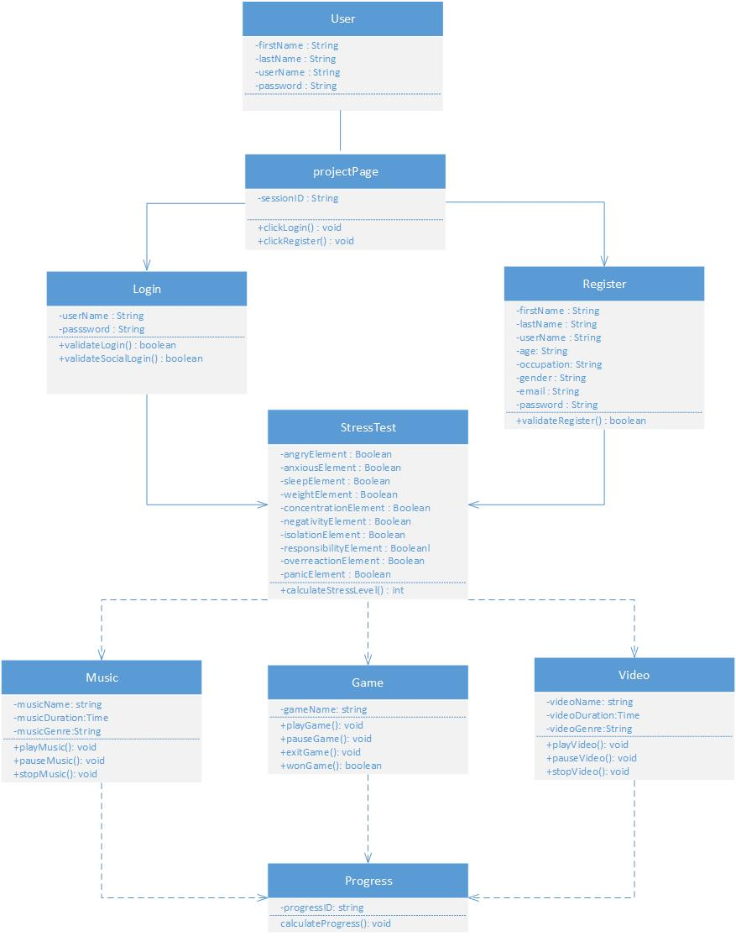

**Use Case Diagram**

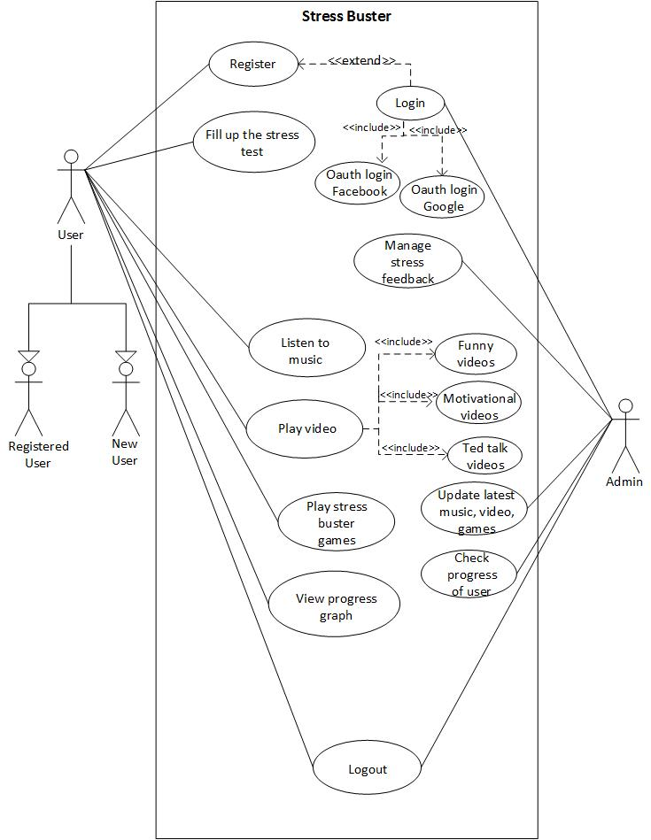

**Activity Diagram**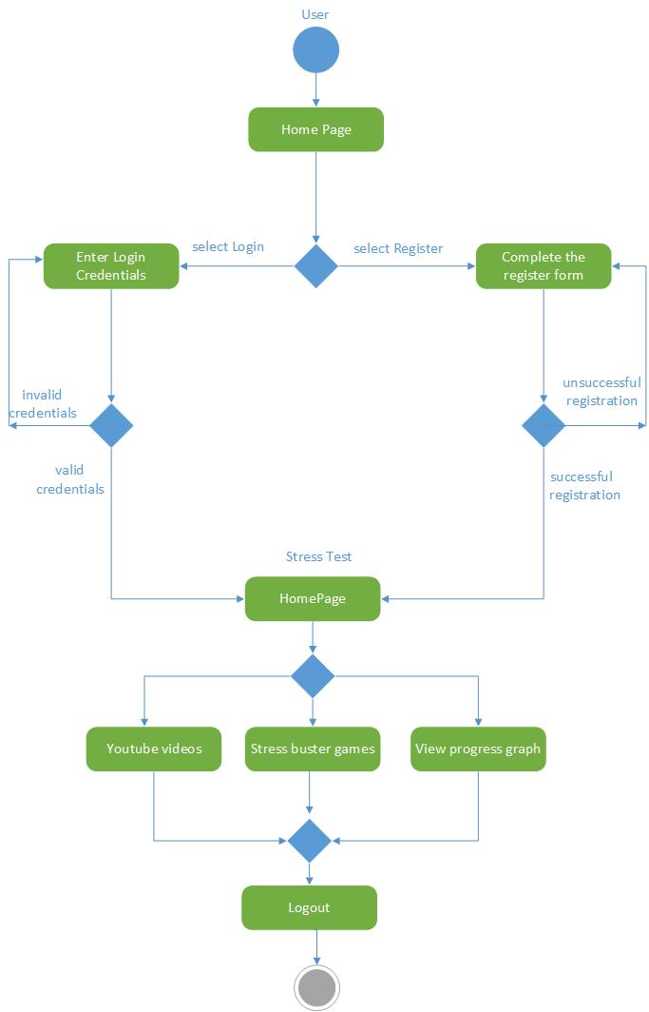

**Sequence Diagram**

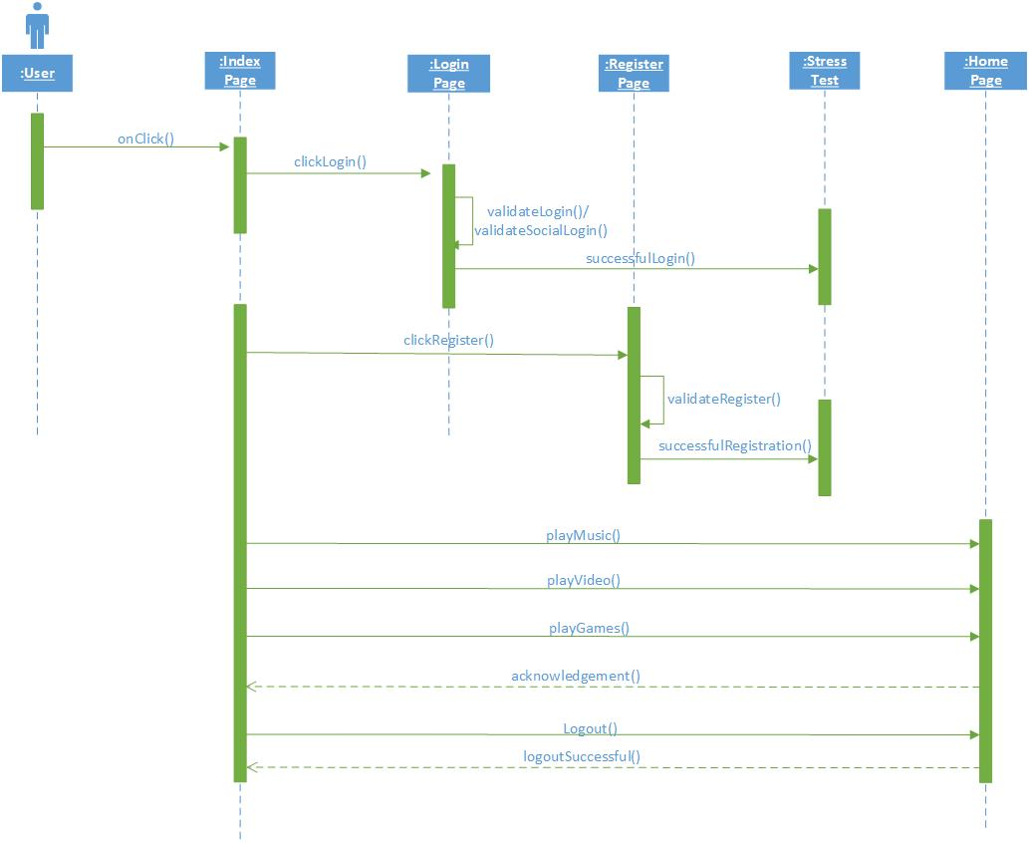

**Architecture Diagram**

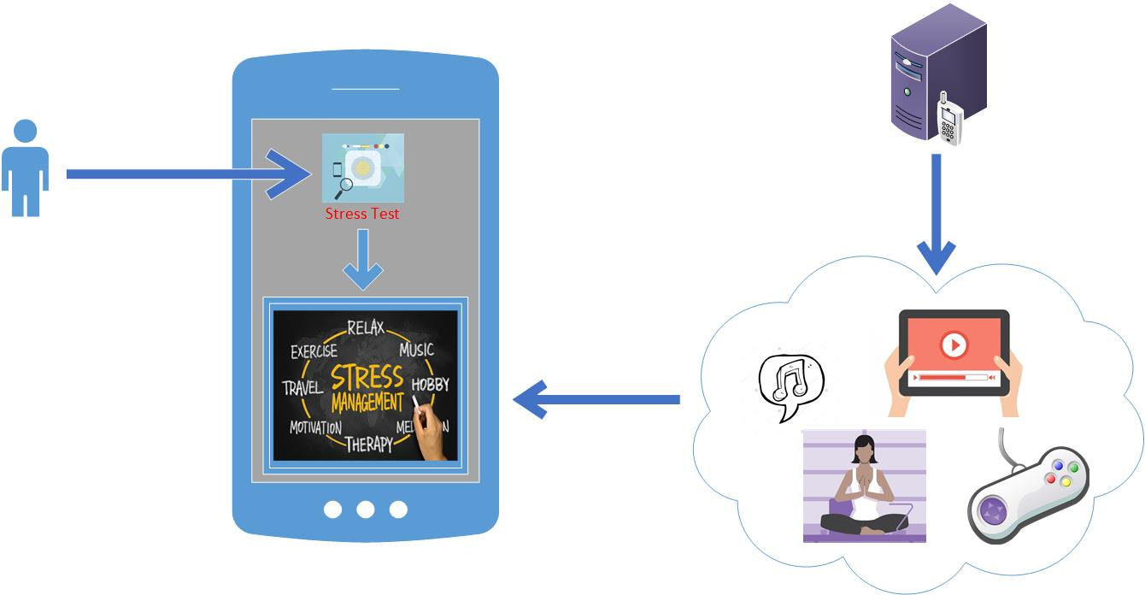

**V. Implementation**

**Launch Screen in Android**

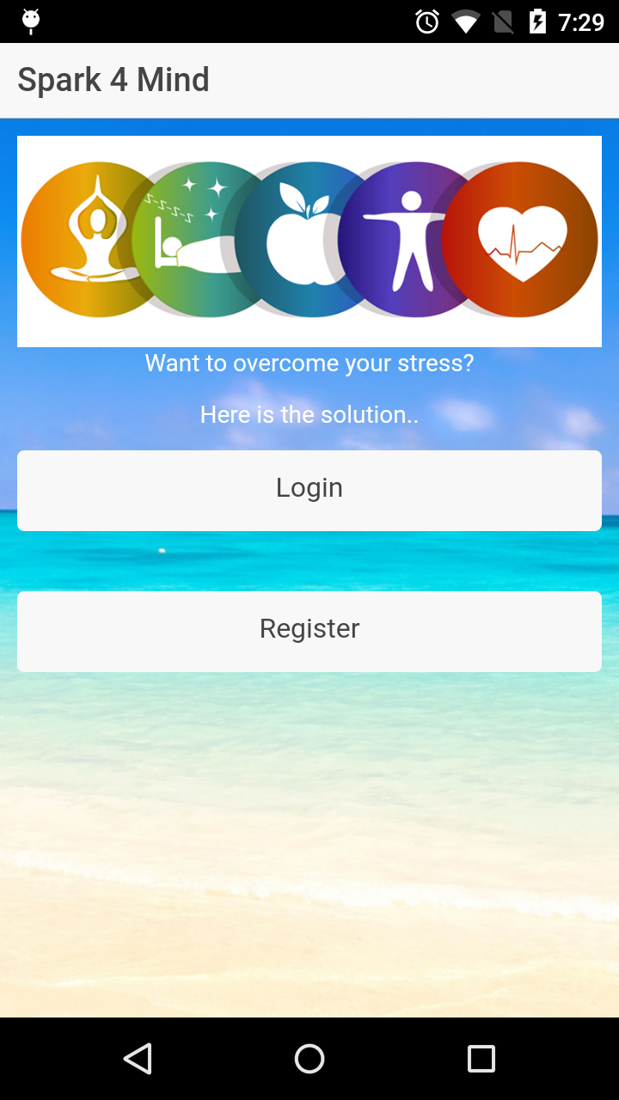

**Login Screen in Android**

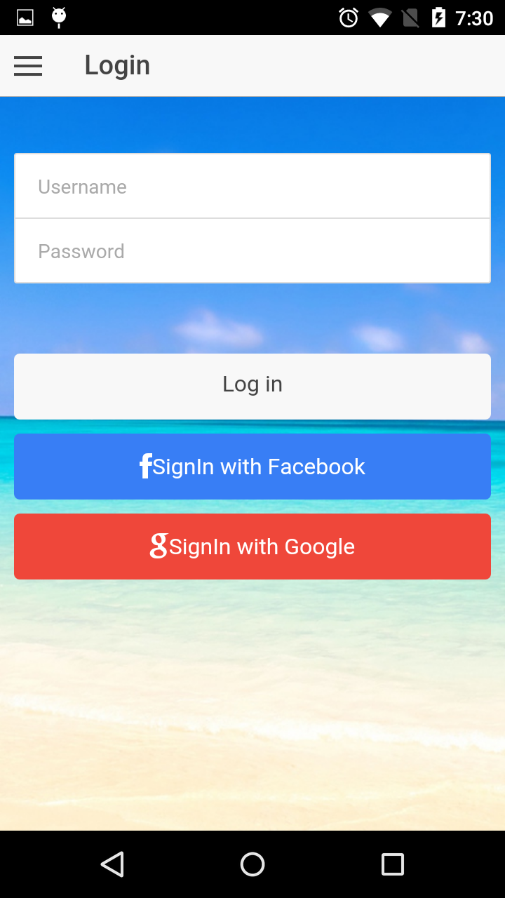

**Registration Screen in Android**

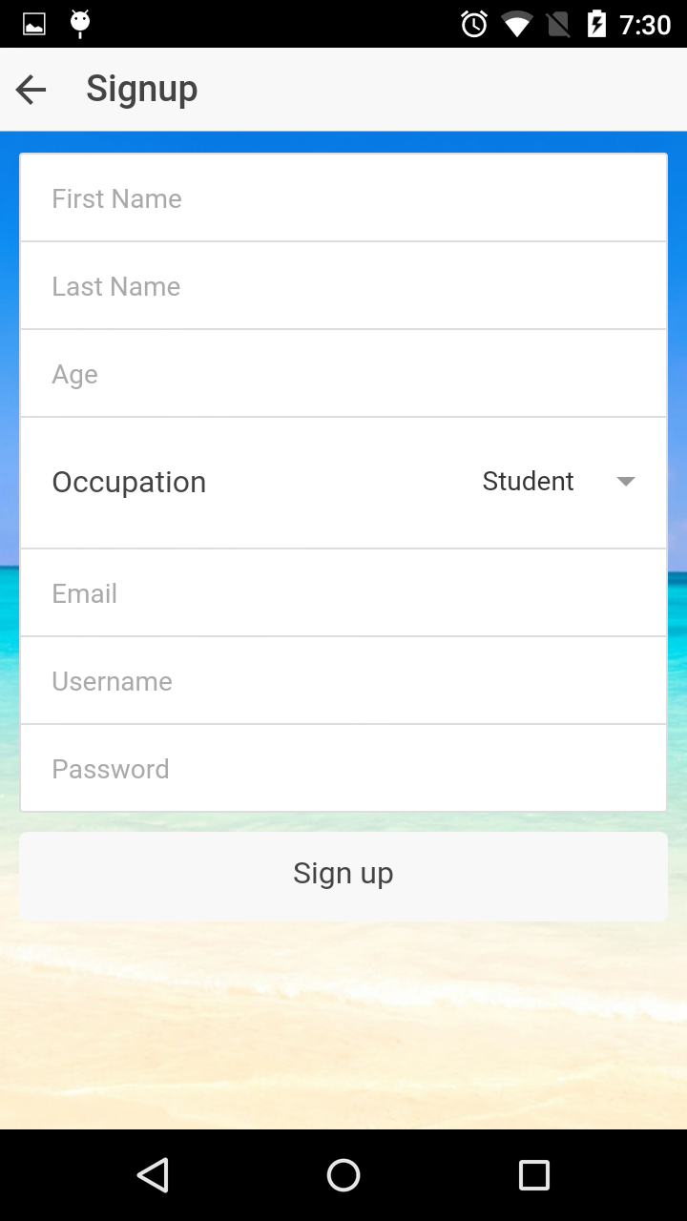

**Settings**

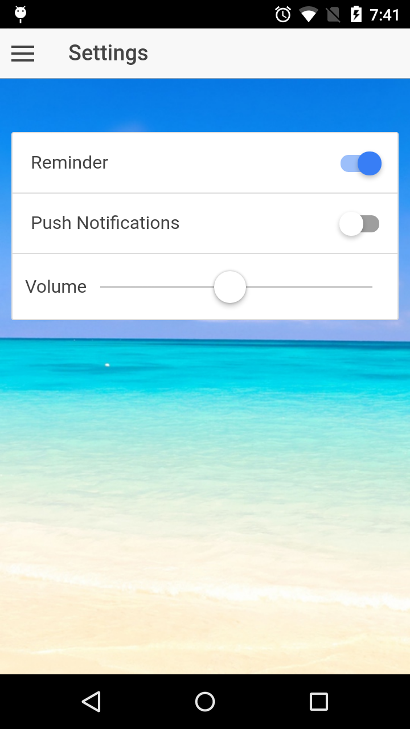

**Stress Test Form Screen in Android**

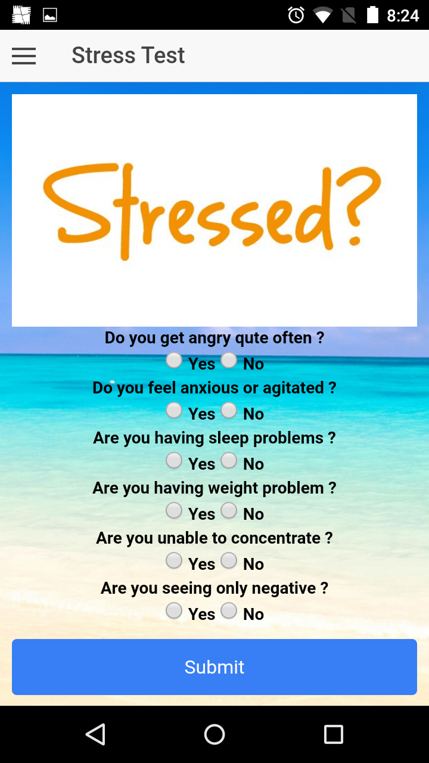

**Home Page**

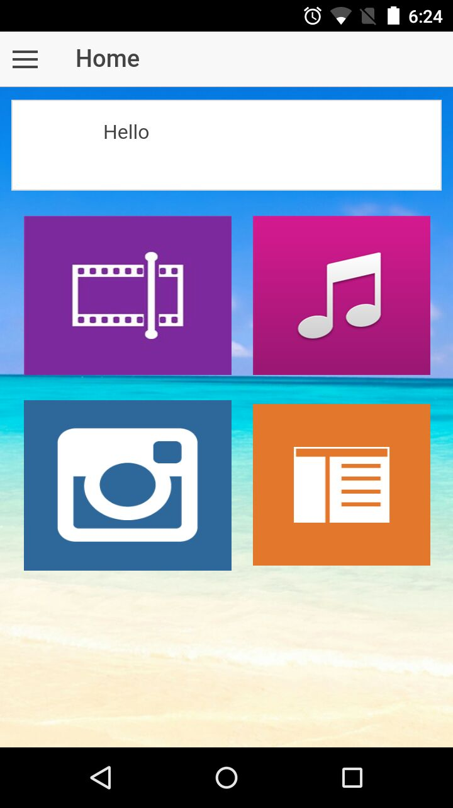

**Youtube Player**

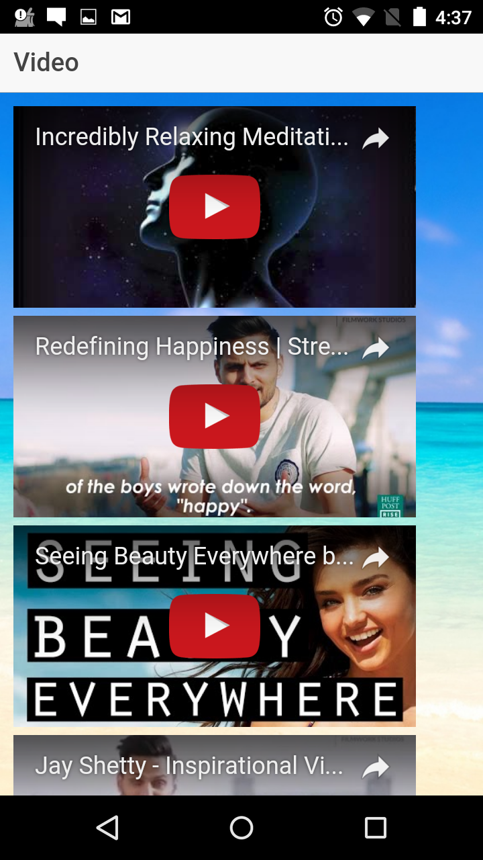

**Gallery**

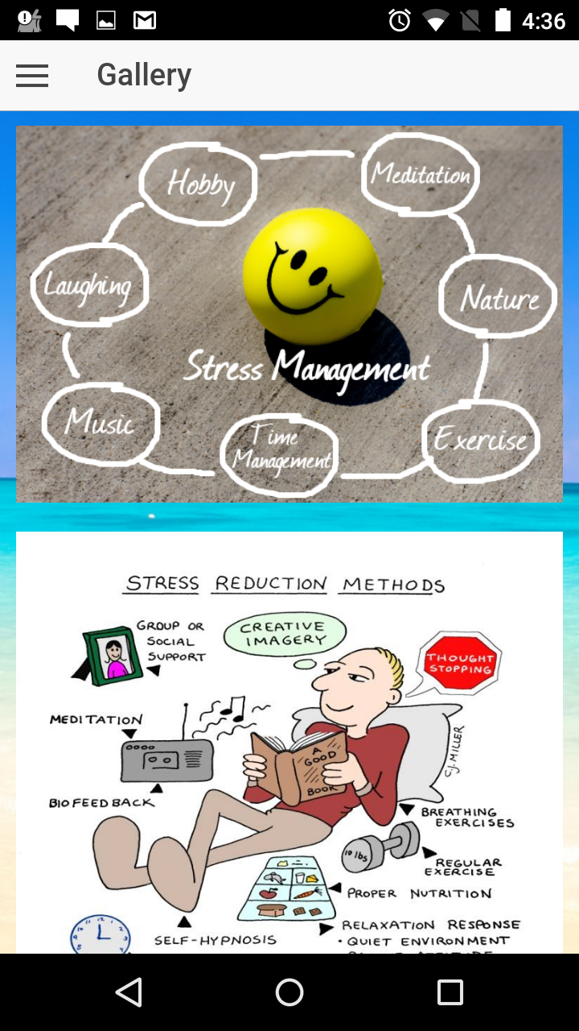

**Side Menu**

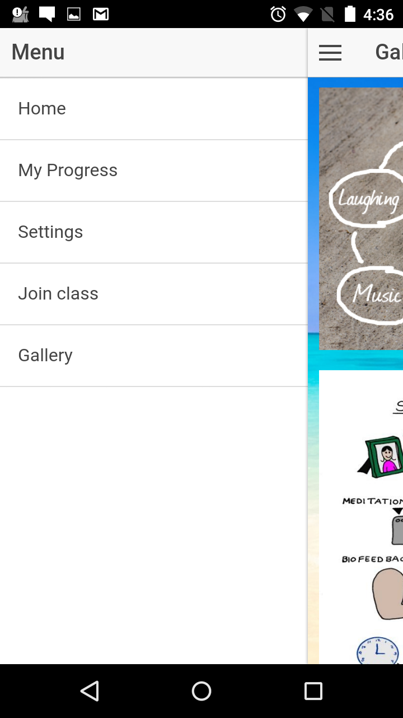

**Class Page**

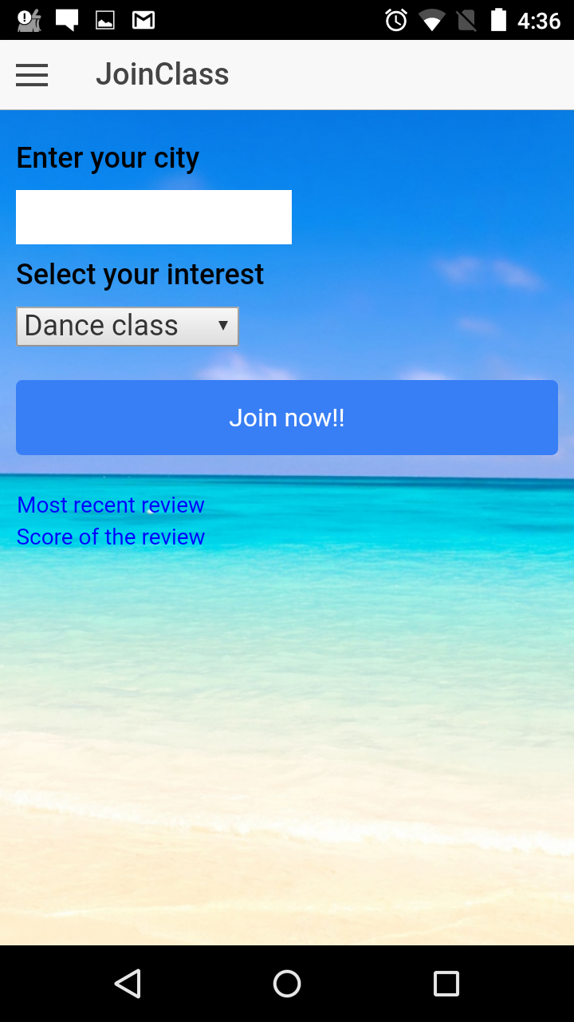

**Articles API**

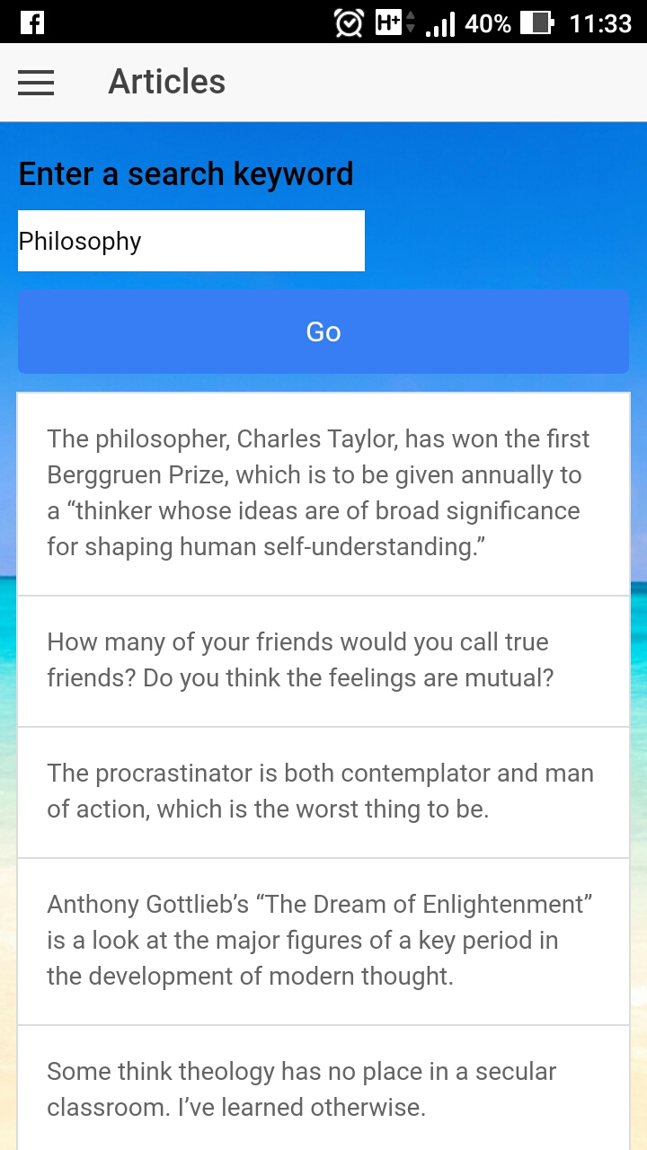

**NYTimes Technology**

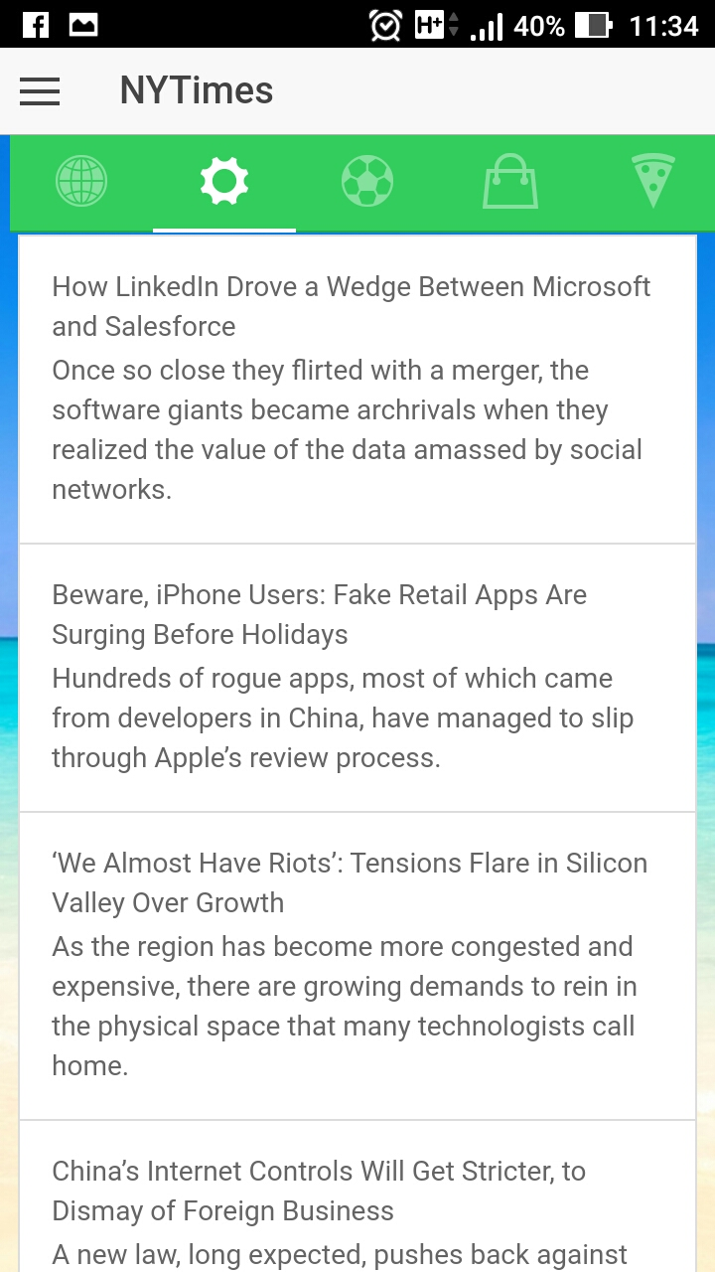

**NYTimes World**

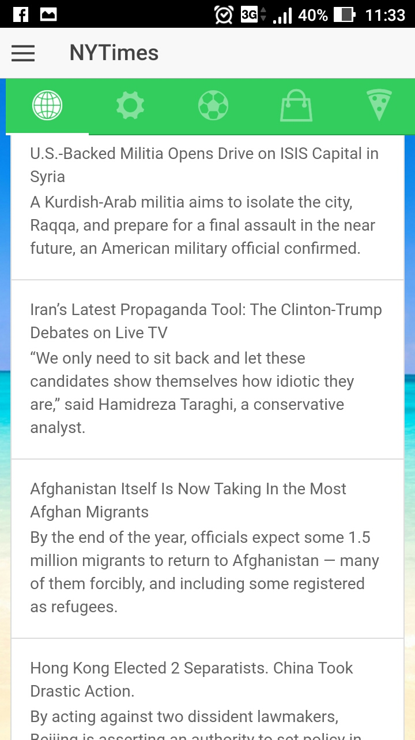

**Music Player**

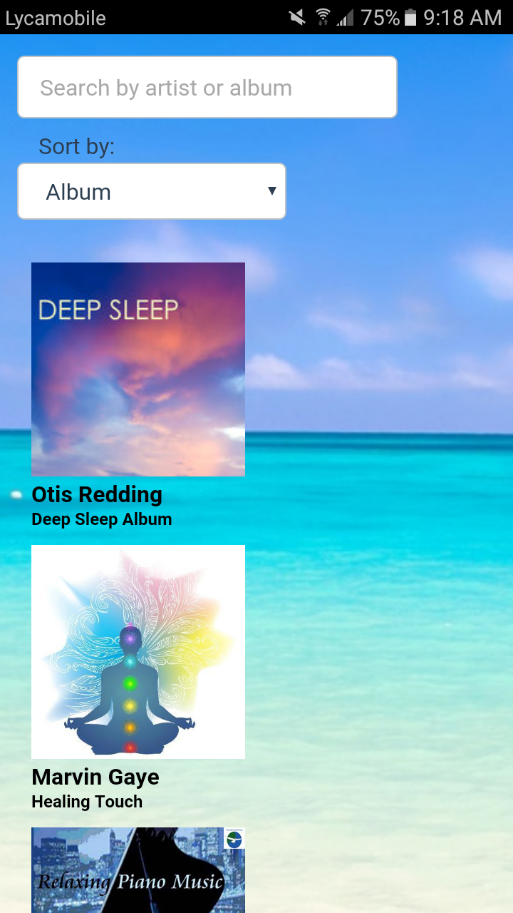

**Album List**

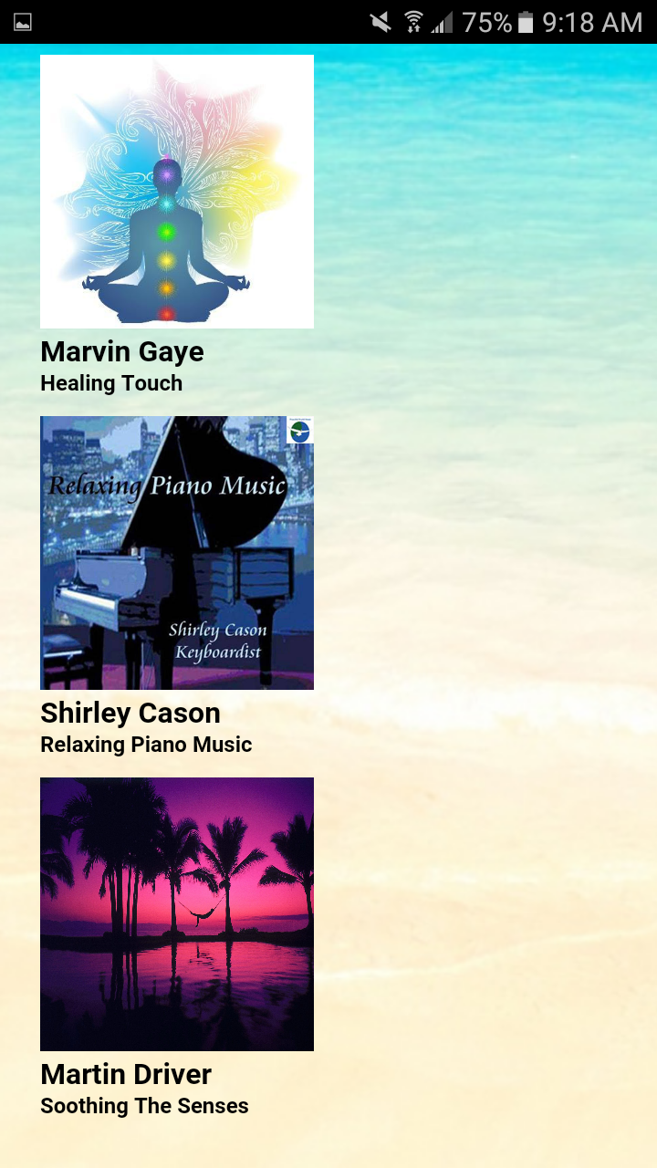

**Album Search**

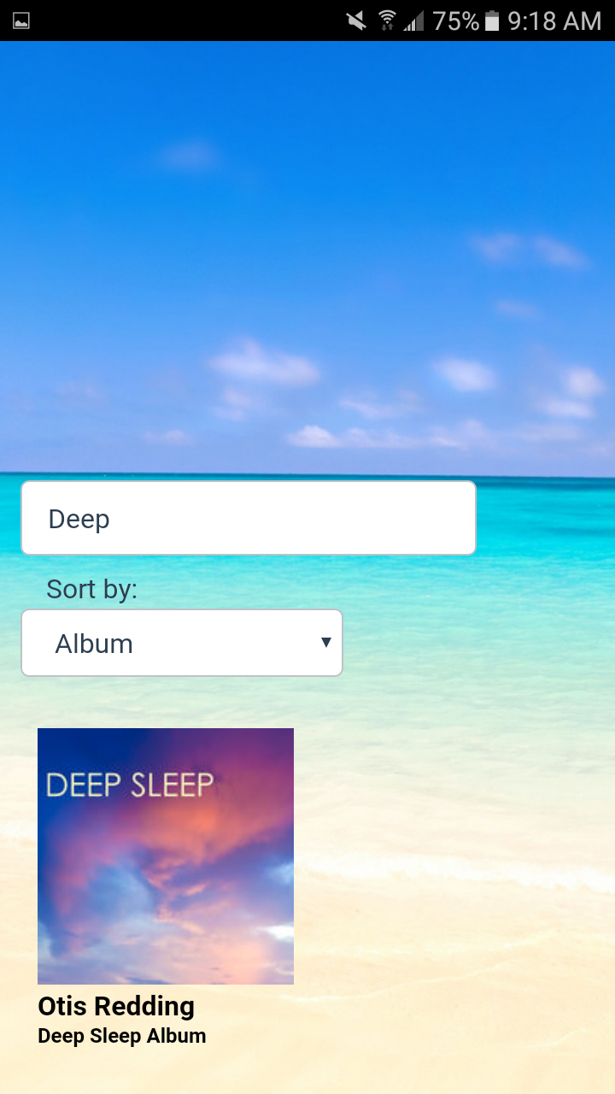

**Sort Album**

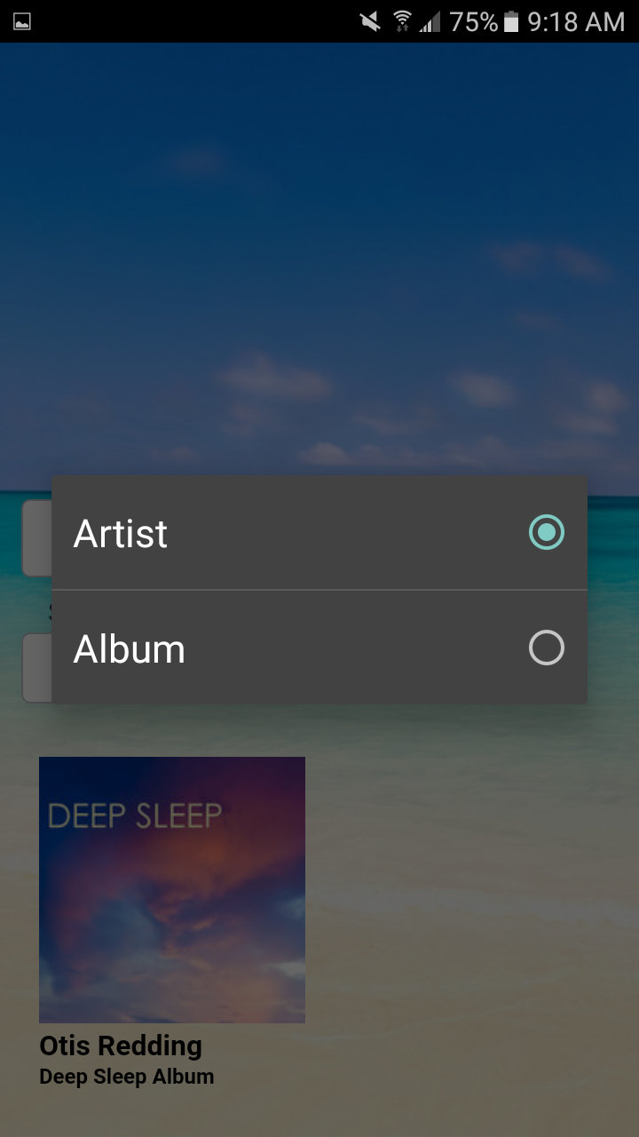

**Song List**

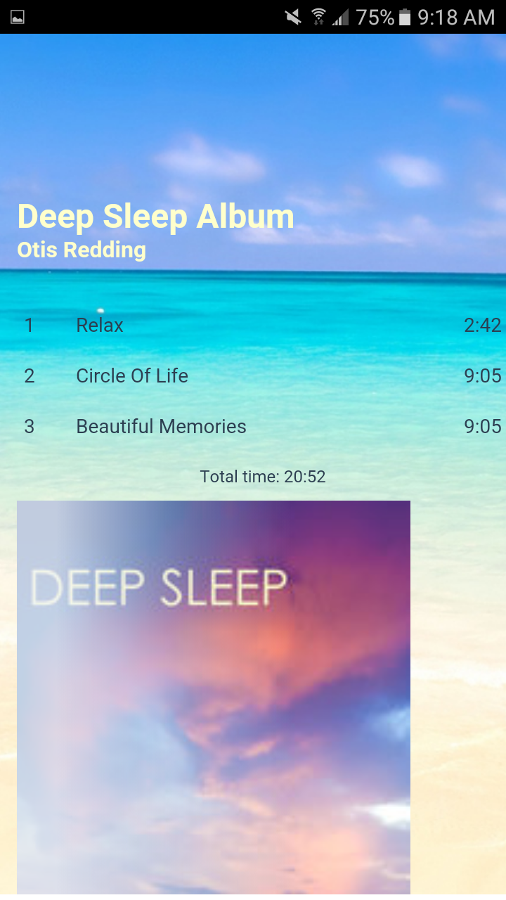

**Playing Song**

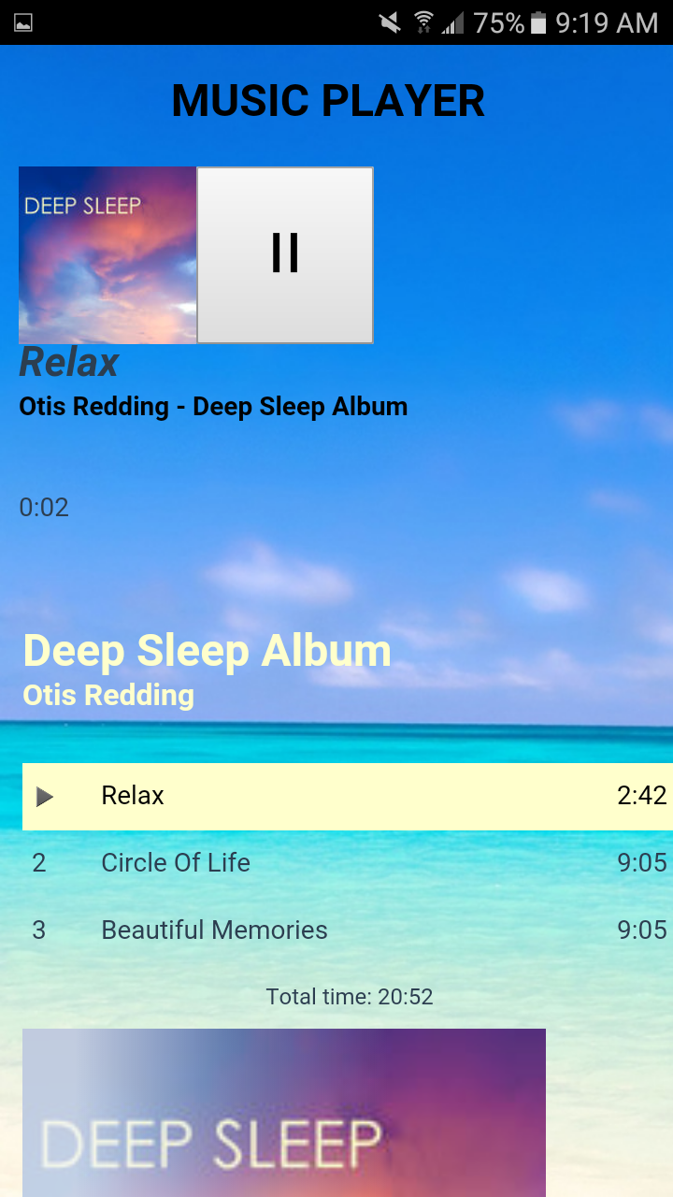

**Feedback**

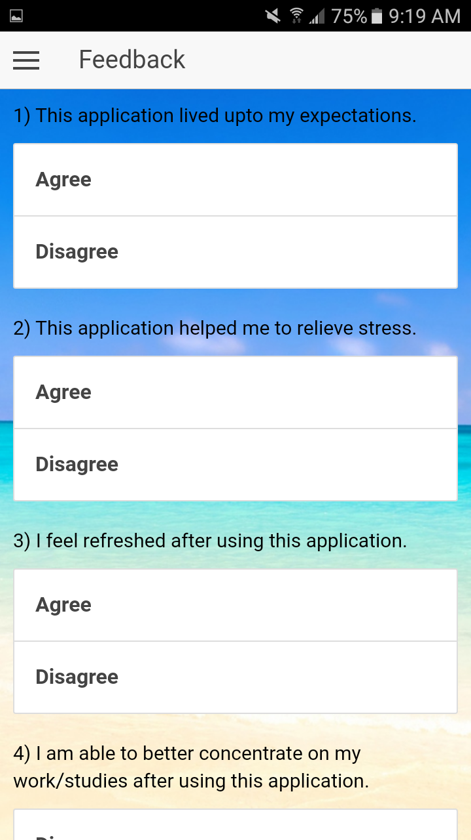

**Feedback Submitted**

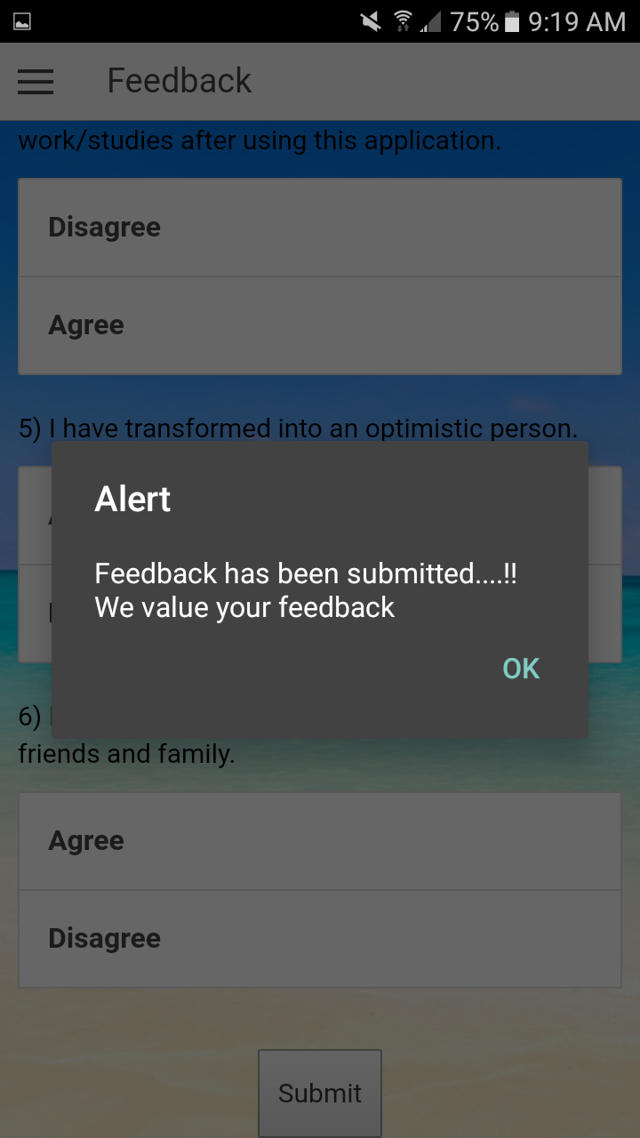

**VI. Testing**

**Unit Testing**

|  |  |  |  |  |
| --- | --- | --- | --- | --- |
| **Sr. No.** | **Test Case** | **Description** | **Expected Outcome** | **Result** |
| **1.** | Successful User Authentication | The user should login with username and password. | Successful Login | Pass |
| **2.** | UnsuccessfulUser Authentication | The user logs in with wrong username or password. | Login unsuccessful with error-Invalid username or password | Pass |
| **3.** | Successful user Oauth Login | The user enters correct credentials in Google or Facebook. | Successful login and transition to Home page | Pass |
| **4.** | Invalid Email ID | Admin accepts registration details from the user. | Successfulregistration and transition to Login page | Pass |
| **5.** | Registration by new user | Invalid Email Id alert. | Error- Enter valid email address | Pass |

**VII. Technology Used**

**Implementation of Mobile Apps- Technology Used**

* Android SDK
* HTML
* CSS
* Ionic
* Javascript

**VIII. Project Management**

**Work completed**

Design and implementation of Launch page::

Launch page consists of basic information about the application with two buttons- Login and Register.

Design and implementation of Login page::

Login page will login into the application and also has Oauth 2.0 social login with Facebook and Google.

Design and implementation of Registration page::

Registration page will retrieve the basic information from the user like- Name, Age, Occupation, Username and Password. Stress is different for people with different age group and different occupation.

Design and implementation of Stress Test page::

Stress Tester page will ask users various questions that will test the level of user’s stress based upon their input.

Design and implementation of Youtube Player::

Based on the level of stress calculated, users can view various funny videos, motivational videos to overcome their stress.

Design and implementation of Gallery page::

Gallery will include an automatic slideshow of images representing various quick fix for stress reliving.

Design and implementation of Join Classes page::

Users can join various classes like music, dance, yoga, exercise based on the user’s location and vicinity to that class.

**Contribution**

* Barath Naravula Loganathan -- 24%
* Aishvwarya Natarajan Iyer – 24%
* Gayathree Natarajan Iyer – 26%
* Megha Nagabhushan – 26%

**IX. Bibliography**

<https://www.ted.com/talks/andy_puddicombe_all_it_takes_is_10_mindful_minutes>

<http://www.techtimes.com/articles/57571/20150605/12-mobile-apps-that-help-relieve-stressand-anxiety.html>

<http://www.mindbodygreen.com/0-2557/Why-Stress-Management-Is-So-Important-for-Your-Health.html>

<https://www.verywell.com/tips-to-reduce-stress-3145195>

<http://www.webmd.com/balance/guide/blissing-out-10-relaxation-techniques-reduce-stress-spot>